Alan D Horn
515733
Contextual Studies
Assignment 3

Plan
Coastal Erosion at Happisburgh, Norfolk

Following submission of my Literature Review, I intent to expand the work into my final extended written project following the format laid out in that document but adding a chapter on the nature and effects of the SSSI.

The chapter headings will be –

1 Introduction
2 What are the causes?
3 What is the extent of the damage?
4 What is the current position in combatting the erosion?
5 What is the significance of the SSSI?
6 What is the future for the community of Happisburgh?

The content of each chapter will cover the following areas –

1 Introduction
This chapter will cover the breadth of the paper whilst introducing diametrically opposed arguments covering-
Protection versus leaving to nature
Moving the village versus protection
British Museum/Natural England and restrictions on protection due to the SSSI
Government departments and advisors disagreeing on facts

See example - attached circa 590 words

2 What are the causes?
This is straightforward in as much as the data is well researched and the focus will be on the British Geological Survey work and historical and current data provided by the North Norfolk District Council (NNDC) and its Coastal Engineer, Brian Farrow.
The effects of climate change will be examined and qualified.
Word count estimate 800

3 What is the extent of the damage?
I will provide the images that I submitted in my Literature Review and further images that I continue to take – that show that the cliffs are increasingly unstable.

I will also use a drone to access areas too risky access on foot but will also give a different dimension.
Word Count estimate 300

4 What is the current position in combatting the erosion?
Time is one thing that Happisburgh does not have. The reaction of Government (DEFRA and Environment Agency) to coastal erosion is contradictory and despite evidence from the Committee on Climate Change (CCC) that the issue far more serious than published Government statistics, there is little evidence that government will intervene. I will attempt to qualify this further.
The NNDC has produced a number of initiatives under their Shoreline Management Plan but these are focussed on managing the erosion rather than controlling it.
I will work with the Coastal Engineer, Brian Farrow to analyse and qualify the significance of these plans for Happisburgh.
I am also in touch with the Chairman (and local councillor) of the Coastal Concern Action Group, Malcolm Kerby who works closely with the NNDC.
Sandscaping at Bacton – is it working and is this an option for Happisburgh?
Images here will consist of the ineffectiveness of current Rock Armour, the old groynes, homes closer to the cliff edge as the erosion increases. Images of properties at imminent risk
Word Count estimate 1400
5 What is the significance of the SSSI?
The SSSI in Happisburgh covers the cliffs where, in 2013, the erosion uncovered what are thought to be the earliest evidence of human footprints outside Africa.
The SSSI status was granted by English Nature (now Natural England) 1985.
I have a conference call with Natural England on 13/12 – Andrew Millar has agreed to answer my 4 questions that are relevant to this paper as well as opening the discussion –
1 What were the reasons for granting the SSSI?
2 Why can't the cliffs be protected from the erosion?
3 What benefits are there in allowing the cliffs to erode?
4 what can / is being done to compensate people whose homes are at risk?
Word Count estimate 800

6 What is the future for Happisburgh?
This will cover the community issues of loss of value in property and inability to get a mortgage on properties close to the cliffs.
There is an inevitability that the village is being left to the ravages of the sea and the rate of erosion is pretty alarming – so what are the options and what can be done to save the community?
According to www.confused.com , Happisburgh is the village most at risk in the UK with an erosion rate of 100mtrs in up to 20 years.
Why can't the cliffs be protected – examples of protected beaches / cliffs
The effects of global warming / sea levels – this will be covered by my link with Alan Brampton of Wallingford – experts on the effect of tides/waves on coastal erosion
Pathfinder fund – can it be repeated or are the villagers' properties doomed?
Interviews with locals
Word count estimate 1100
Word count total estimate 5000

Fig 1
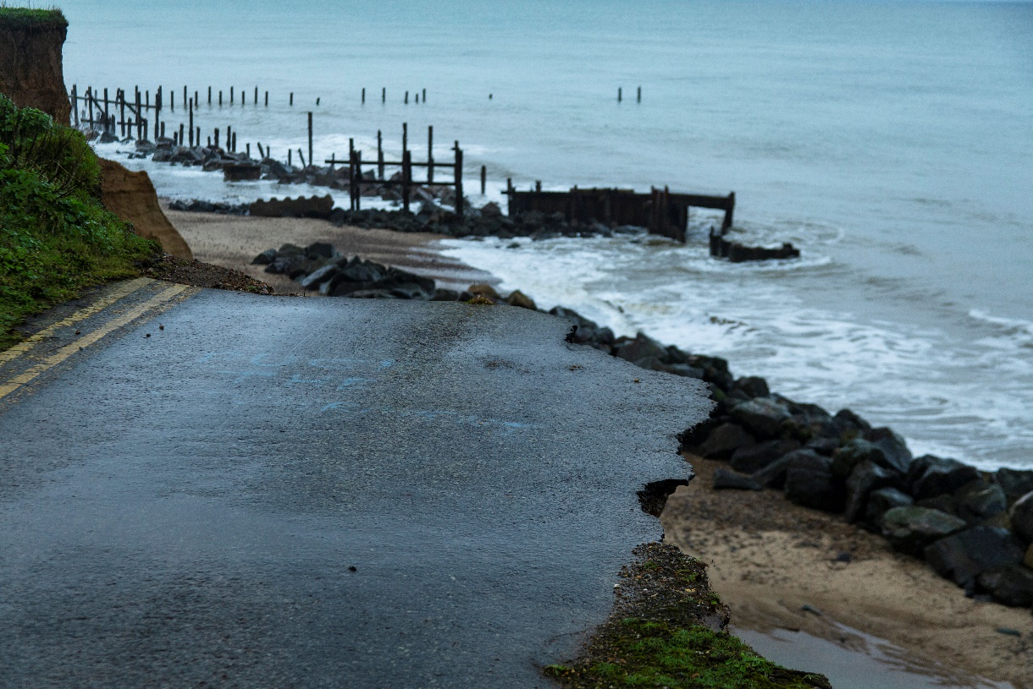
Further collapsing of a side road

Fig 2
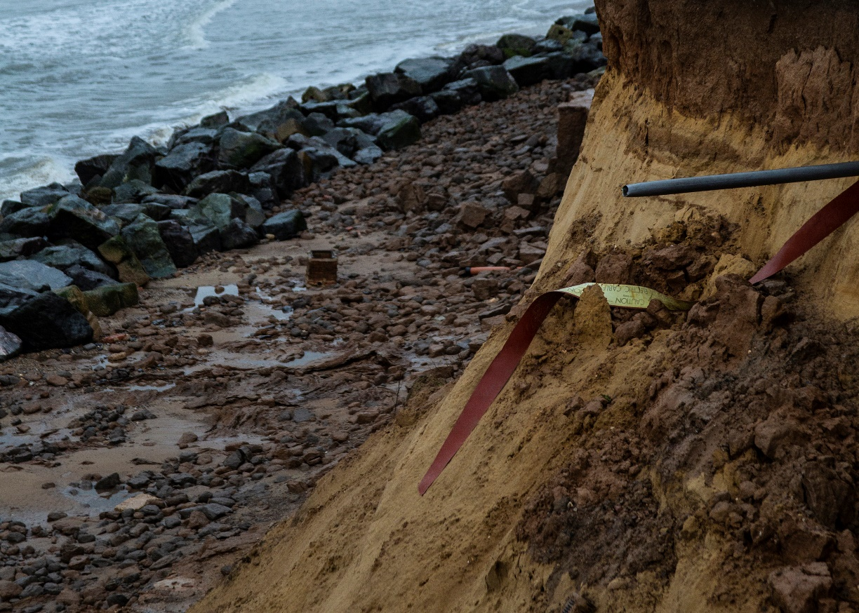

An old chimney stack from an outbuilding and continuous erosion of upper soil layer due to heavy rainfall
Fig 3
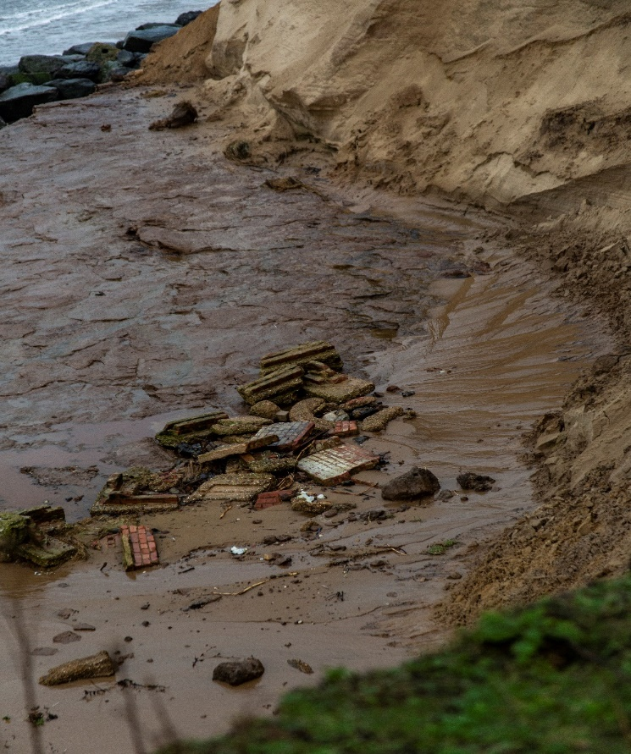
Remains of an outbuilding

Fig 4
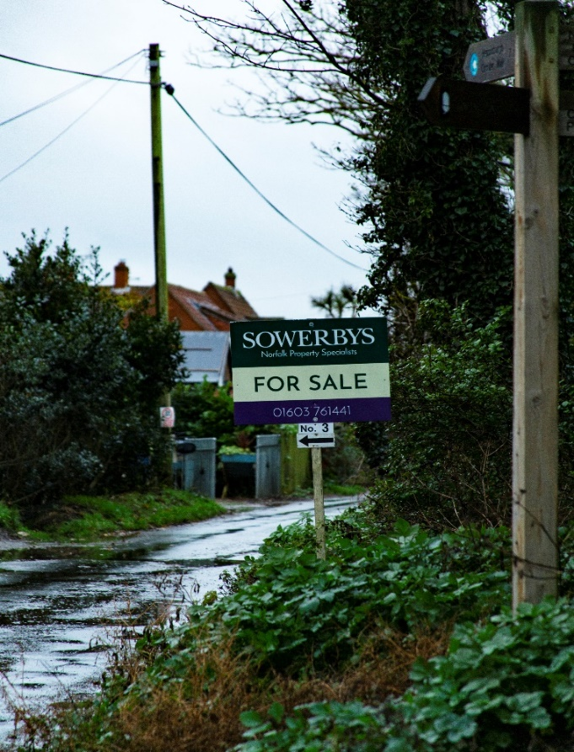
No 3 Coastguard Cottages for sale (Nov 2019) at £190,000 but mortgage "not available"

Fig 5 No3 Coastguard Cottages

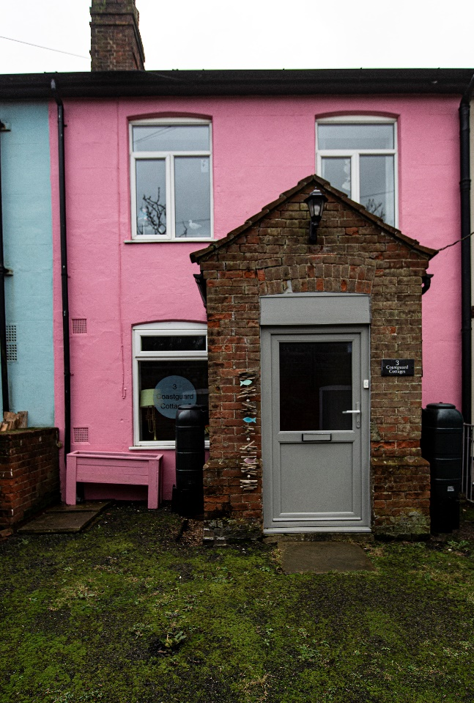

Fig 6
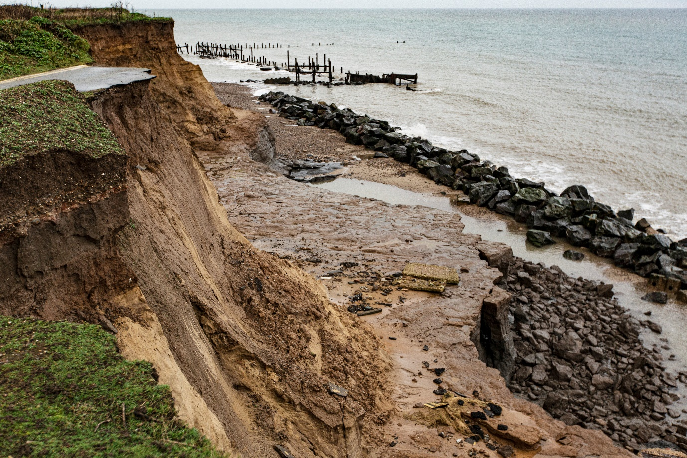

Fig 7
